May 2024 ETBCC Meeting Minutes

The meeting was held at “Tennessee Jack’s” in Morristown, TN on Thursday May 2nd 2024. It was convened at 7:04 pm by vice president Carl Floyd with about 7 members present, two guests and three British cars in the parking lot.

The Treasurer’s report was sent by Mark Bourne with $698.22 on deposit after the following: Notable transactions include $356.16 paid to Jim Watson as reimbursement for his purchases related to the 2024 April Fool’s Bash and the addition of $177 (and change) received from ABCS as 50% reimbursement to our club for the agreed to 50/50 split for cost of Bash. Club also owes me $20 for State Corporation Annual Report Form that I paid with my personal CC.

Old Business:

After Action Report for the 2024 April Fools Bash: The event hosted by the Morristown club and the Kingsport club at Sky Ranch Airport off of ALCOA Highway in south Knoxville on April 6th was deemed to be a success by all who attended. Carl said it turned into a wings and wheels event with about 50 cars present and people enjoyed seeing all the private planes at the airport. Attendees said it was a great venue and hope to go there again..

40th Springtime in the Smokies: The actual show will be Saturday May 11th at Tally Ho Inn located in Townsend TN. Gate opens at 9 am. This is the main event in this area for British car enthusiasts and lots of fun.
English Auto society of Knoxville

New Business:

Drive your British Car Week: May 25th thru June 2nd is “Drive your British Car Week”. Please participate. It is a club event, so restrictions of antique license plates to weekend use, maintenance, and car club events would be covered.

Roster of Active Members: Mark Bourne posted a new roster of active members who are caught up on their dues is on the website.

Next Meeting: offered his community pavilion for a club meeting sometime this spring and said he would contact Green Tomato as a potential caterer. Our next meting date is June 6th, so that would be our last chance for a Spring meeting there. Location TBA.

Tires: Oh, excuse me; Tyres: Julian Dufour reminded us of the importance of tire conditions, not just proper tire pressure but tire age. If the DOT Code is three digits, the tire is old. If it is four digits the first two digits are the week it was manufactured and the second two are the year.

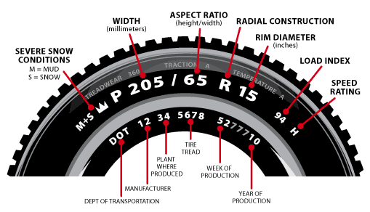

Meeting adjourned about: 7:22pm

Submitted by Larry Peck, Secretary ETMGDC

Please send any corrections that should be made to these minutes to me.

